Dr. Shawn MacKenzie FACS FRCSC
Hepatobiliary & Pancreas Surgical Oncology
Minimally Invasive General Surgery
Suite 306 - 301 East Columbia Street, New Westminster
www.HPBsurgeryRCH.com
Ph: (604) 970-1096 Fax: (604) 800-0221

PATIENT INSTRUCTIONS

ALL patients are required to bring their 1) CareCards, 2) the completed Questionnaires/forms, and 3) a list of all current medications. We are located at SUITE 306 – 301 EAST COLUMBIA STREET, across the street from the Royal Columbian Hospital Emergency Room Entrance. Pay parking is located in the lot next to the building on East Columbia Street.

There is a $50.00 NO SHOW PLOICY which must be paid prior to rebooking the missed appointment.

We work hard to see your patients in a timely fashion, however please note that due to factors within the healthcare system which are beyond our control, this is not always possible. Should your condition worsen or if you feel the referral is urgent, please contact your GP to request an urgent referral to Dr. MacKenzie.

YOUR DOCTOR’S OFFICE HAS BEEN INSTRUCTED TO

PLEASE NOTIFY YOU OF YOUR APPOINTMENT DATE AND TIME AND PROVIDE THE NECESSARY FROMS FOR YOU TO FILL OUT PRIOR TO YOUR APPOINTMENT.

FORMS: 4 page Fraser Health Preoperative Surgical Questionnaire, consent to use electronic communications, and Dr. MacKenzie’s 1 page Patient Questionnaire. Please complete all questionnaires/forms prior to the office visit. Printable copies of the questionnaires/forms can be found on our website at www.HPBsurgeryRCH.com. If the questionnaires are not completed prior to the appointment, the you must arrive 30 minutes early to complete the documentation prior to seeing the surgeon.

REQUIRED DOCUMENTATION: Your GP has been asked to please forward all CT scan, MRI, Ultrasound, and relevant Lab results to the office prior to the scheduled appointment. Please notify the office if any of the recent imaging has been performed outside of the Fraser Health Authority.

SCHEDULING DELAYS: Please be aware the surgeon may be urgently called away from clinic. In the event of a Trauma, a serious illness, or a very sick patient at RCH, Dr. MacKenzie may be required to perform emergency surgery during a regular clinic day. If this was to occur your patient may have a 1 to 2 hour wait for their scheduled appointment or may need to be rescheduled at the last minute.
APPOINTMENT REMINDERS:
Patients must respond to text messages, emails, or phone calls CONFIRMING the appointment. ***FAILURE TO CONFIRM APPOINTMENTS WILL RESULT IN CANCELLATION***
Appointments must be confirmed at least 5 days prior to the appointment date.

Please provide our office with a valid patient SMS phone number or email contact for all communications regarding appointment scheduling

10 days prior to the scheduled appointment you will receive a SMS text message reminder:

“Jane, you have been referred to Dr. MacKenzie and have been booked an appointment on January 1st, 2018. Text 1 to confirm this appointment. If you need to make changes to this appointment, please call (604) 970-1096. Press 2 if you no longer require this appointment.”

If you select confirmed you will receive a return text, and you are confirmed:

“Appointment for January 1st, 2018 is confirmed. For any further changes call (604)970-1096.”

1 day prior to the scheduled appointment you will receive a second reminder:

“Reminder Jane, about your appointment on January 1st, 2018 with Dr. MacKenzie”

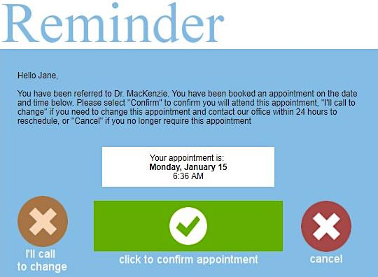

If you do not have SMS text capabilities, the reminder will be sent as an email:

If you do not have email capabilities, the reminder will be sent via automated electronic voice reminder.

